**Lecture Note-Numerical Analysis (7): Linear Algebraic Equations**

1. **LU decomposition (Lower-Upper decomposition): Also, it is called LU triangularization**

**- Main Philosophy**

**To resolve** 



* **The matrix****can be decoposed as**



**where** **is a lower triangular matrix and** **is an upper triangular matrix**

 

* **Then, the linear system** **can be easily solvable as**



**with one back substitution to get** **and one forward substitution to get** 

**(Question) How to decompose** **?**

**Answer: LU decoposition method**

**(Question) The LU decoposition method is much more efficient than Gauss elimination method?**

**Answer: Yes for the large-size linear system**

1. **Crout LU-decoposition method**

* **It use unit lower triangular matrix, which means the diagonal elements of L are all 1.**

 

* **1st step to calculate** 





* **2nd step to calculate** 



 🡪 

* **3rd step to calculate** 



 🡪

* **4th step to calculate** **It use unit lower triangular matrix, which means the diagonal elements of L are all 1.**



 🡪 

* **To calculate** 





🡪

* **To calculate** 





🡪

1. **The Matrix Inverse**



* **Using above definition, we can define n-linear algebraic equations to get each** **as**



By resolving each equation, we can get column vectors . Therefore, we can

calculate the inverse matrix 

* **Matrix Inverse Using LU decomposition**



 🡨 

 🡨 Backward substitution

 🡨 Forward substitution

1. **Operation Count of LAE solver**

**(4-1) LU-decomposition**



* **In calculating** 



addition/substraction:  for each k 🡪 j-th row

multiplication/division:  for each k 🡪 j-th row

Total addition/substraction



Total multiplication/division



* **In calculating** 



addition/substraction:  for each k 🡪 k-th column

multiplication:  for each k 🡪 j-th row

Total addition/substraction



* **In Forward substitution**

addition/substraction : 

multiplication : 

* **In Backward substitution**

addition/substraction : 

multiplication : 

* **Total operation count in LU-decomposition**

addition/substraction:



Multiplication/division:



**(4-2) Cholesky-decomposition about half of the LU-decomposition**

addition/substraction: 

Multiplication/division: 

**(4-3) Naïve Gauss-Elimination**

* **Operation Count of Gauss Elimination Methods**

**For forward elimination of j-th column**



 number of addition/substraction for j = (n-j)



number of multiplication/division for j = (n-j)



* **In Backward substitution**

addition/substraction : 

multiplication/division :



* **Total operation count in Gauss-Elimination**

addition/substraction:



Multiplication/division:



1. **Operation Count of LAE solver: Comparison**

* **The operation count for the Cholesky decomposition is about the half of those of Gauss-Elimination & LU for a large dimension n**
* **However, the computation of an inverse matrix using the Gauss-Elimination needs n-times of matrix inversion, while LU & Cholesky-decompostions need only one decomposition.**

1. **Vector Norm, Matrix Norm, and Condition Number**

**(6-1) Vector norm**

* Norm is a real-valued function that provides a measure of size or “length” of vectors and matrices. Norms are useful in studying the error behavior of algorithms.

Mathematical definition of vector norm:  If the following conditions are satisfied, we call  is the vector norm of 

1. ,  iff 
2. 
3.  🡪 Triangular inequality

where **V** is the vector space and **C** is the complex number space.

* Example of the vector norm: *p*-norm: You can prove the *p*-norm satisfies the conditions (1)~(3).

Definition of *p*-norm for 



1-norm with *p* = 1 : 

2-norm with *p* = 2 :  ,which is called by the “Euclidean Norm”

-norm with *p* = : 



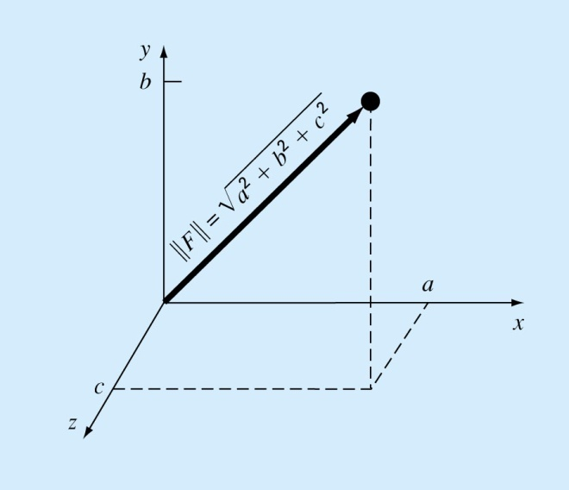

**(6-2) Matrix norm**

* For the general matrix, the matrix norm is defined by the same way as the vector norm as

1.  iff  where 
2. 
3.  where  🡪 Triangular inequality

* We usually prefer the matrix norm that is represented by a vector norm. For this purpose, the **subordinate matrix norm** is defined by

 for 

For the **subordinate matrix norm**, the following relations are hold.



Example

1-norm: 

-norm: 

* **Frobenius norm** which provides a single value to measure the size of 



**(6-3) Condition Number and Error dependency of the linear algebraic equation**

* The matrix condition number is defined by



* The effect of the matrix condition number on the solution of the linear algebraic equation represented

by can be estimated by examining when there exists a small perturbation in the and  such as .

Then



From 

 (a)

From , we obtain . Therefore,

 (b)

By combining two equations (a) and (b),



As a result of the above equation, the error in the solution due to the perturbed right-hand-side is directly proportional

to the matrix condition number.

* **Condition Number provides a measure of the difficulty in solving the linear system.**

**(The linear system with high condition number can cause serious round-off error)**

**(6-4) Relation of the matrix norm with the eigenvalues**

Definition of the Eigen-value problem of a matrix 



We call and as the eigen-vector and the eigen-value related to , respectively.

From the above definition of the **subordinate matrix norm**, repeated here as

 for 

With,



Therefore,



Also, the eigen-value of the inverse matrix of  can be obtained by



Which says that has the same eigen-vector  but its eigenvalue corresponding to the eigen vector  is the reciprocal of . Therefore, the condition number can be expressed as



**(6-5) Example with the 3x3 Hilbert matrix**





By solving the polynomial equation, you can obtain



You can compute the condition number using the MATLAB command of **cond(H)** such as

>> H =[

1.0000 0.5000 0.3333

0.5000 0.3333 0.2500

0.3333 0.2500 0.2000];

>> cond(H)

ans =

524.0568